SACRAMENT OF BAPTISM
(Children under 6 years old)
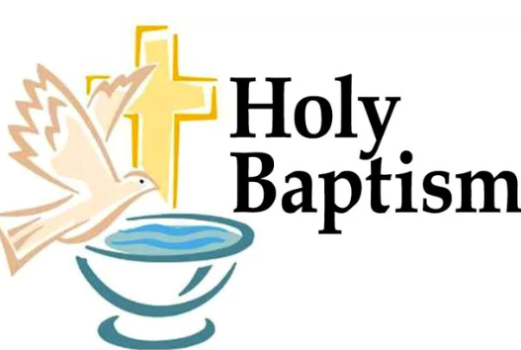

1st STEP:
Parents who wish to baptize their children must choose good godparents. Godparents act as a guide of the Catholic faith to the child; therefore, they must be baptized, confirmed, and be active members of the Church. If they are married, they must be married in the Catholic Church. Sponsors must be good Christians who practice their faith so that they can set a good example for the child and are willing to assume the responsibilities that being a sponsor implies.

2nd STEP:
The parent(s) need to come into the office to register the child.
(Tuesday – Friday 10:00 A.M. – 5:00 P.M.) The registration form will be filled out by office staff.

- The child’s original/official birth certificate and a $70.00 cash administrative non-refundable fee is required at time of registration. No exceptions. CARDS AND CASH ONLY.

- If the Godparents are a couple living together, they need to be married through the Catholic Church and provide us with that certificate.
If Godparents are single and not living as couple with anyone, they need to bring certificates of their Baptism, First Communion and Confirmation.

Godparents: Only one male, or female sponsor, or one of each sex is permitted. They have to be older than 16yrs of age & have all their sacraments.

3rd STEP:

- Parents and Godparents need to attend (1) pre-baptismal class.
The English class occurs on the 1st Saturday of every month in the classroom next to the office from 5-7pm.
The Spanish classes are on the 1st and 4th Saturday of the month from 7pm-9pm in the church, right after mass.
Please do not bring children.
If the class is taken at another church, we will need written proof.

After the class is taken and all documents are received, come to the office to choose the baptism date.

Baptisms in Spanish are the 1st, 3rd, & 4TH Saturday of the month (subject to change) 11am.
Baptisms in English are the 2nd Saturday of the month @ 11am.

Only 10 children will be baptized at one time. If the date you want has been filled, you will need to choose another date.

**WE DO NOT RESERVE OR HOLD DATES. ALL REQUIRED DOCUMENTATION IS NEEDED IN THE OFFICE BEFORE A BAPTISM DATE CAN BE PICKED**

***IT IS ADVISABLE TO PREPARE AT LEAST 6 MONTHS IN ADVANCE. ***

*** EFFECTIVE IMMEDIATELY: NO REFUNDS***

NOTICE: We do not provide nor endorse any photographers for baptisms. You may bring your own photographer at your expense. NO FLASH PHOTOGRAPHY.

The parents will receive their child’s baptism certificate after the baptism.

DOCUMENTS CAN BE SENT BY E-MAIL TO office@stedwardstockton.family, please on the subject, write the child’s full name.

Saint Edward’s Parish
731 South Cardinal Avenue
Stockton, CA 95215
(209) 466-3020

